Demo Video Script

# Video

Video Link:

<https://youtu.be/yOVbVA1GfIY>

[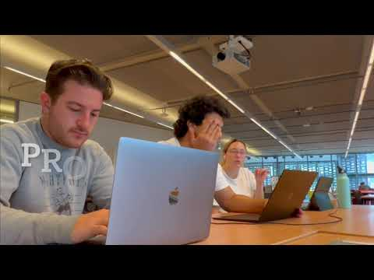](https://youtu.be/yOVbVA1GfIY)

# Individual Contribution:

The project team collaborated on the *Project Demo Video* tasks equally. We made sure to communicate project needs and distribute tasks equally and fairly.

# README

Project Demo Video README

41014 Sensors and Control for Mechatronic Systems

Project Title: DOBOT ROBOT HAND-EYE CALIBRATION PROJECT​

Contributors: Group 9

13868233 Britney Malone

13899947 Sebastiano Guarna

13900081 Vince Pirina

The project team collaborated on the Project Demo Video tasks equally. We made sure to communicate project needs and distribute tasks equally and fairly.

Overview:

This submission contains the Project Demo Video for the DoBot Robot Hand-Eye Calibration Project by Group 9. The video provides an overview of the project, its objectives (to achieve a DoBot Robot Hand-Eye Calibration Project following the given task), key project features, and any other relevant project evidence. It is designed to give viewers an understanding of the project's purpose and significance.

Video Content:

The video covers the following project aspects:

- Code Based Challenges

- Simulated DoBot Simulation Movements

- Physical Hand-Eye Data Collection

- Calibration

How to Access the Video:

The Project Demo Video can be accessed through YouTube.

YouTube:

The video is available on YouTube at the following link: https://youtu.be/yOVbVA1GfIY